

**Roseville Secondary School Enugu**

**A project of Ikota Educational Foundation.**

**First Term 2024/2025 ACADEMIC SESSION**

**SUBJECT: ECONOMICS**

**CLASS: SS1**

**EXPECTATIONS**

1. Copy your note **or** print and spiral bind
2. You are expected to be with your note, textbook and workbook for every class
3. Three graded assessment of 20 marks before CAT = **60%**
4. CAT: **40%**
5. Non-graded assessment
6. Project to be submitted in **Week 6**
7. Three graded assessment of 20 marks before exam= 60%
8. Examination **40%**

**NAME OF TEACHER:** Mrs. Obioma Jessica – Williams Chukwudubem

**FOR ENQUIRIES: chukwudubemobioma@gmail.com**

**07068669387**

**SCHEME OF WORK**

|  |  |
| --- | --- |
| **WEEK** | **TOPICS** |
| **WK1** | Meaning of Economics and Related Concepts |
| **WK2** | Methods and Tools of Economics Analysis |
| **WK3** | Concept of Demand |
| **WK4** | Concept of Supply |
| **WK5** | CAT |
| **WK6** | Continuation on CAT/Open Day |
| **WK7** | Theory of Production |
| **WK8** | Division of Labor and Specialization |
| **WK9** | Scale of Production |
| **WK10** | Economic System and Basic Economic Problems of Every Society |
| **WK11** | Revision |
| **WK12** | Examination |

**WK 1: MEANING OF ECONOMICS AND RELATED CONCEPTS**

**Lesson Objectives;**

1. Students should be able to:
2. Discuss the meaning of Economics.
3. Explain the basic concepts of Economics
4. Demonstrate the relevance of basic concepts of economics to day-to-day human activities and decisions.
5. Recognize why economics is a science and social science

**INTRODUCTION**

**Economics** has many definitions because different economists see the subject from different perspectives and as such, they define economics to reflect their interests. Economics generally is the study of the wellbeing of peoples and nations. It studies how individuals, businesses, governments, and nations make choices on how to allocate resources.

Let’s consider some definitions of Economics given by some Economists;

**Adam Smith,** defined Economics as “**an inquiry into the nature and causes of the wealth of nations**.” He is regarded as the father of economics because he laid the foundation for economics as a discipline

**Alfred Marshall**, defined "**Economics is a study of mankind in the ordinary business of life”**. He emphasized that economics has something to do with the study of human beings in relation to their daily economic activities.

J.S. Mill, saw **''Economics as the science of production and distribution of wealth**". He was more interested in what determines the amount of wealth an individual possesses or how wealth is produced and shared out among the various members of society.

A.C. Pigou, saw “**Economics as the existence of material welfare** “. In his view, economics is all about acquiring material wealth which improves the welfare of human beings.

Paul A. Samuelson defined "**Economics as the study of how men and society choose, with or without the use of money, to employ scarce productive resources which could have alternative uses, to produce various commodities over time and distribute them for consumption now and in the future amongst various people and groups of society**".

H.J. Davenport saw “**Economics is the science that treats phenomena from the standpoint of price**”. He looked at economics as something that has to deal with things that have a price value (For anything to be of any economic importance, it must have a price attached to it)

Prof. Lionel Robbins gave a more scientific definition of Economics. He defined “**Economics as the science which studies human behavior as a relationship between ends and scarce means, which have alternative uses**". This definition focuses on scarcity and choices which are fundamental problems in the daily economic activities of man.

**SCOPE OF ECONOMICS**

All economists, despite the varying views, still agree on the following as the scope of Economic:

* **Economics is a social science**: It studies man’s behavior and the activities aimed at satisfying human wants. These activities are; Production, Exchange, Distribution and Consumption
* Economics deals with how people react daily to changes in economic situations
* Economics deals with how individuals, businesspersons and the government make use of limited resources at their disposal to maximize utility.
* Economics focuses on reality i.e. “what is”, “what was”, and “what will be”.
* Economics studies the working or functioning of institutions and processes such as banks, international economic organizations.
* In a nutshell, an economist is one who knows how best to allocate his limited resources/means. To maximize his utility. He is not a miser but knows how to use his time, money and other resources, to obtain the maximum benefits.

NB: See page 4 in your textbook for details

**REASONS WHY THE STUDY OF ECONOMICS AS A SUBJECT**

1. It helps to solve the basic economic problems of the society
2. It helps in making rational choices by drawing scales of preference
3. It helps to promote welfare by emphasizing opportunity cost
4. Helps the individual to understand the economic policies of government e.g. budget
5. It helps individuals to acquire skills which are useful in various jobs and professions.
6. It helps to train the mind to reason logically
7. It is useful in the study of other disciplines like engineering, business administration etc.

See details on pages 8-9 in your textbook

**REASONS WHY THE STUDY OF ECONOMICS IS IMPORTANT TO SOCIETY**

1. Helps individuals in objective, critical and rational thinking.
2. Helps individuals understand national economic issues.
3. Helps individuals make rational choices using their scarce resources
4. Helps the government manage its resources in terms of income and expenditure
5. Helps firms to know how to manage their resources and their production plans
6. Guides the government in formulating development plans
7. Is a requirement for further studies/entry into other professions

**ECONOMICS AS A SCIENCE**

Economics is a science because it adopts scientific methods. This involves the following;

* Observation;
* Formulating a hypothesis;
* Collecting data;
* Organizing.
* Analyzing the data
* Draw conclusion

**ECONOMICS AS A SOCIAL SCIENCE**

Economics is a social science because it studies human behavior. E.g. If the price of a commodity rises, people will buy less, other things equal. It studies how consumers try to maximize their satisfaction, given their income and prices of the commodities.

BASIC CONCEPTS IN ECONOMICS

**Wants**: Man’s insatiable/unlimited desire or need to own goods (tangible commodities) or services (intangible commodities) that give satisfaction. Wants are also known as Ends..



**Needs**: These are our desires that are basic for our existence and survival. They are the desires that we cannot avoid satisfying.



**Resources**: This refers to the means with which human wants/needs can be satisfied, including all the factors of production. These resources are scarce when compared with competing wants.

**Scarcity**: This refers to the limited supply of resources needed to satisfy our unlimited wants. This gives rise to the economic problem and is the main reason for the study of Economics. Economics is therefore concerned with allocating the limited resources among competing and unlimited wants

**Choice**: This is the decision made over various options, based on the available resources. It involves rational thinking in the selection and satisfaction of the most pressing wants.

**Price**: The amount of money paid by the buyer to the seller, in exchange for any product or service.

**Value**: The usefulness of any product to a customer. This remains unchanged irrespective of the changes in the market.

**Demand and Supply**: Demand refers to the quantity of a commodity that a buyer is able to afford and willing to pay for, given its price, at a particular time. Supply on the other hand is the quantity of a commodity a seller/producer is willing and able to supply/sell at a particular price and time, Ceteris Paribus (all things being equal).

**Scale of Preference**: This is a table or list showing the arrangement of our wants in their order of importance. Individuals, firms and governments are faced with the problem of allocating scarce resources among competing unlimited wants. In doing this, they draw a scale of preference and make choices. Scale of Preference is important because it;

* is a tool for the arrangement of wants in order of priority
* enables individuals, firms and government to make rational choices in the list of want
* facilitates optimum allocation of resources
* enables economic agents to maximize their satisfaction
* enables economic agents utilize their scarce resources efficiently
* assists in managing our finances prudently

**Opportunity Cost**: This occurs when a want is satisfied at the expense of another. The satisfied want is its “Money Cost”, while the forgone want is the Opportunity cost/Real Cost/True Cost/Forgone Alternative. This buttresses the fact that “Nothing in life is free” there is always a tradeoff. Opportunity cost is important to;

* Individual: Wise choices, efficient use of scarce resources
* Firms: Rational decision in production process and techniques of production
* Government: Budget preparation and decision making process

**Value of Money**: This refers to the quantity of a commodity/service that a certain amount of money can buy/pay for at a particular time. The value of money is affected by Inflation (increase in prices of goods and services overtime).

**Purchasing Power:** This goes hand in hand with the time value of money. Purchasing power goes down as inflation rises

**Alternative Uses**: Not only are resources scarce, they also have alternative uses e.g. coal, money etc. If there was only a single use of the resource then the economic problem would not arise.

**BRANCHES OF ECONOMICS**

Economics is grouped into two major divisions;

**Micro-Economics:** The branch of economics which deals with smaller units or components of the economy. It analyzes basic decisions of households, individuals, firms and governments. Advantages include;

* Better understanding of the various units of the economy
* It helps with policy making
* It helps the government to know the vibrant sectors of the economy
* It also assists in developing economic tools for solving economic problems.

NB: The data gotten from micro economic principles are not always reliable, this is a major disadvantage.

**Macro-Economics**: This refers to the branch of economics that deals with larger units or broad aggregates of the economy. Advantages include;

* Even distribution of income
* Provision of goods and services
* Full employment
* Price stability
* Economic development
* Balance of payment (BoP)

The disadvantages include;

* Difficulty in analyzing data due to volume
* Negative grouping of data without considering the particular nature of the economic components.

**Pure Economics:** This involves the study of laws and theories derived from the study of economic behavior.

**Applied Economics**: The application of laws and theories in analyzing and solving economic problems.

**Monetary Economics**: The study of money and banking.

**Business Economics**: The study of trade, business organizations and accounting.

**Development Economics**: The study of economic planning and national economies.

EVALUATION

The students should answer the following questions

* 1. What is Economist
  2. List basic concepts of economist
  3. 3. List importance of Economist

ASSIGNMENT

Is economics a Science or Art? Give reasons to support your answers.

SUMMARY

Economics seeks to study the relationship between ends and scarce means. These scarce means can be put to alternative uses so we have to arrange our wants in order of preference and make choices so as to maximize the available resources. Simply put, Economics is the study of Scarcity and Choice.

**WK 2: METHODS OF ECONOMIC ANALYSIS.**

**Lesson Objectives;**

1. Students should be able to
2. Describe basic economic tools, state their uses and importance
3. Construct a frequency distribution
4. Calculate the mean, median and mode of any given data.
5. Explain simple economic relationships with tables, graphs and chart.
6. Appraise the merits and demerits of the tools

INTRODUCTION

Basic tools of economic analysis are the basic tools that are used in interpreting and analyzing economic problems, thus making them easier to understand. Some of these tools include;

* Tables
* Graphs
* Charts
* Measures of central tendency (Mean, Median and Mode).
* Simple Linear Equations
* Measures of dispersion (Range, Mean Deviations, Variance and Standard Deviations).

TABLES

This is a systematic and orderly arrangement of information’s, facts or data using rows and columns. It is the most commonly used tool for economic analysis. Where you have more than one table, each table must have a unique number for easy referencing.

NB: for uses and features of tables, refer to page 12 in your text book.

Example of a Table

|  |  |
| --- | --- |
| Number of pen bought | Price(€) |
| 2 | 500 |
| 4 | 400 |
| 6 | 300 |
| 8 | 200 |
| 10 | 100 |

GRAPH

This is a diagram showing functional relationship between 2 variables. Information presented on table can be translated into graphs for better understanding. Most popularly used are line graphs (used to reflect activities that change overtime e.g. inflation, interest rates etc.).

A line graph is a diagrammatic representation in which a line is drawn between scaled vertical and horizontal axis to show continuous change. It could be straight or curved

**Relevance of graph in economics**

* it helps in illustrating some basic concepts
* it is used to introduce lessons
* it reflects the association of two or more variables
* it allows for easy understanding of information

NB: Features of a good graph: refer to textbook, page 16-17.

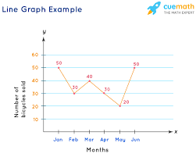

CHARTS

These are sketches of tabulated data that show the relationship between variables, so as to aid further understanding.

**Types of charts**

1. **Pie Charts**

This is a graph of simple circle of any convenient size which is subdivided into sections /sectors each of which is proportional to the quantity or value it represents. It is usually measured in percentage or degrees.

NB: For advantages and disadvantages, see pg 18



1. **Bar Chart**

This is a graph made up of bars of rectangles which are of equal width and whose length are proportional to the quantities they represent. They can be arranged vertically or horizontally. it is of 3 types

1. **Simple Bar Chart**: used to represent data involving only one variable

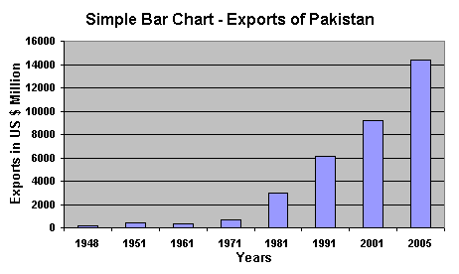

1. **Component Bar Charts**

This is used when the data involved are more than one. The bars are divided into components to show each aspect of the data. It is also known as stacked chart.

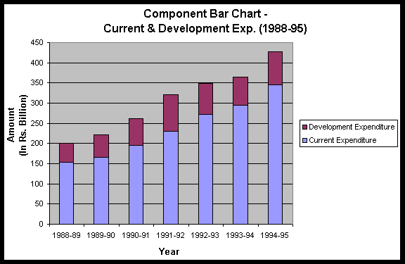

1. **Multiple Bar Chart**

This is used where there are 3 or more variables in a given set of data. it has multiple bars each of which stand for a component variable.

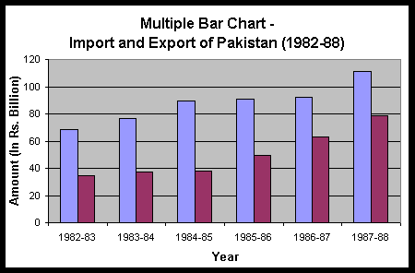

1. **Pictorial Chart**

This is a chart which uses pictures to represent data in a simple way. It is also known as pictogram.

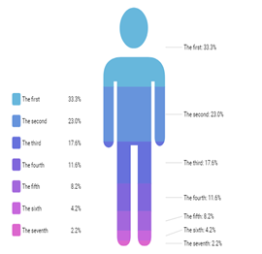 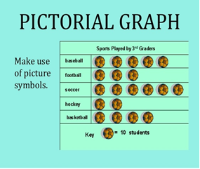

HISTOGRAM

This is similar to a bar chart, a histogram condenses data by grouping them into logical ranges. it measures data on an interval scale.

NB: for advantages of Histogram, see page 19

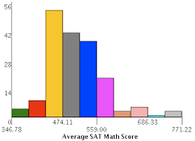

**MEASURES OF CENTRAL TENDENCY**

A measure of central tendency is a single value that tries to describe a set of data by identifying the central position within that set of data. It is also called measure of location. There are 3 main measures of central tendency;

* **MEAN**

This is the average of a series of figures/values. It is obtained by dividing the sum of the figures by the total number of the figures/values. It is also the average of a collection of observation. It is expressed mathematically as ***𝚺𝒙 / n*** *(for ungrouped data) or* ***𝚺fx / fx*** *(for grouped data)*

* **MEDIAN**

This is the middle value when figures/datas are arranged in order of magnitude in an even distribution with either the smallest or the largest. It is given by the formula ***(n + 1 / 2)th*** when n is odd number

* **MODE**

This is the most frequently occurring number in a given set of data

NB: Refer to text pages 20-26 for merits and demerits of measures of central tendencies

FREQUENCY DISTRIBUTION

This shows the number of times each figure appears in an array. It presents datas on class intervals ( for grouped data) and frequency.

|  |  |  |
| --- | --- | --- |
| scores | Tally | Frequency |
| 6 | 11 | 2 |
| 5 | 111 | 3 |
| 8 | 1 | 1 |
| 2 | 1111 | 4 |

**CLASS WORK 1**

Solve for the mean, median and mode for the following data;

4, 2, 6, 4, 7, 1, 1, 3, 5, 8

**CLASS WORK 2**

A village consist of twenty (20) households with the following annual income:

30, 20, 50, 40, 60,

40, 40, 50, 20, 60

80, 40, 20, 20, 70

40, 70, 30, 40, 80.

Determine the following income:

1. mean
2. median
3. mode
4. prepare a frequency distribution table

MEASURES OF DISPERSION

They are known as measures of variation. The application of measures of dispersion is used to determine the degree of spread of the numerical value of a distribution. These measures include:

1. **The Range**: difference between the highest and lowest value in the data.
2. **Mean Deviation**: measures the dispersions around the arithmetic mean. It is obtained by determining the arithmetic mean of all absolute deviations from the mean. The value of each deviation from the mean is determined with an utter disregard for the sign. it is given by the formula *𝚺*d/n or *𝚺*fd/n
3. **Standard Deviation**: this is used in determining the extent to which data deviate .it is the square root of the variance. it is given by the formula SD=√∑f(x-x)2/n or =√∑(x-x)2/n
4. **Varience**: This is the square of standard deviation or the average of the square about the deviations of the measurement. it is given by the formula variance= ∑f(x-x)2/n or =∑(x-x)2/n

**Class Work 1**

Study the table below

|  |  |
| --- | --- |
| Marks | frequency |
| 20 | 2 |
| 30 | 4 |
| 40 | 6 |
| 50 | 8 |

Determine the following

1. Mean deviation
2. Variance
3. Standard deviation
4. Range

**LINEAR EQUATIONS**

This is of form y=ax+c where x and y are variables, and a and c are constants. Where the values of a,x and c are known, the values of y can be determined. They be represented diagrammatically or graphically.

NB: Calculations will be done in class

**Classwork 2**

In the linear equations y=2x- 5, determine the values of y when x ranges from -2 to 4

EVALUATION

The students should answer the following questions

1. List the measures of central tendency
2. Differentiate between bar chart and Histogram
3. List Measures of Dispersion and solve calculations involving it.

ASSIGNMENTS 1

The table below shows the marks obtained in an economics exam. Using the table, calculate

|  |  |  |  |  |  |
| --- | --- | --- | --- | --- | --- |
| MARKS | 20 | 30 | 40 | 60 | 80 |
| FREQUENCY | 3 | 2 | 1 | 4 | 3 |

* 1. the mean mark
  2. the modal mark
  3. the median
  4. construct a frequency distribution table

ASSIGNMENT 2

The marks scored by physics students in WAEC 2021 examination is presented below.

|  |  |
| --- | --- |
| Marks | Number of students |
| 5 | 3 |
| 10 | 4 |
| 20 | 2 |
| 30 | 1 |
| 40 | 6 |

Calculate

1. Range
2. Mean deviation
3. Variance and Standard Deviations

SUMMARY

The tools of economic analysis give a concise and understandable interpretation and analyses of problems initially presented in statements and difficult to understand. These tools basically allow for proper analysis of economic problems.

**WK 3: CONCEPT OF DEMAND**

**Lesson Objectives;**

Students should be able to:

1. Define demand
2. State the laws of demand
3. Discuss the factors that affect demand.
4. Develop demand curves from demand schedules
5. Enumerate the types of demand
6. Compare the various types of demand and their interrelationships
7. Differentiate between shift in and movement along demand curve
8. Distinguish between change in demand and change in quantity demanded
9. Explain factors that affect shift in demand and movement along demand curve

MEANING OF DEMAND

This refers to the quantity of goods (product) or services a consumer is willing and able to buy, at a particular price and time. Demand may be defined as the ability and willingness to buy a specific quantity of goods and services at a given price and at a particular period of time.

In economics, demand is quite different from want or need. In order to differentiate demand from need or want, economists usually talk about effective demand. Effective demand is defined as a desire backed up by ability and willingness to pay for specific quantities of a commodity at alternative prices and within a period of time.

LAW OF DEMAND

The law of demand states that all things being equal, the higher the price, the lower the quantity of goods that will be demanded AND the lower the price, the higher the quantity of goods that will be demanded.

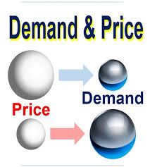

FACTORS AFFECTING DEMAND

* Price
* The price of other commodities
* Income of the consumer
* Changes in taste of consumer
* Population
* Periods of festivals
* Taxation
* Weather and climate
* A good Advertisement
* Government policy

DEMAND SCHEDULE

This refers to a table that shows the quantities of a commodity demanded at various prices, at a particular time. Types include;

**A. Individual Demand Schedule**

It is a table that shows the different quantities of a commodity which an individual( or consumer) would purchase at various prices and at a particular time.

|  |  |  |  |  |  |
| --- | --- | --- | --- | --- | --- |
| Price per tin ($) | 100 | 80 | 60 | 40 | 20 |
| Quantity demanded | 10 | 20 | 30 | 40 | 50 |

NB: The above demand schedule is in consonance with the law of Demand

**B. Aggregate/Market Demand Schedule**

This is also known as composite demand schedule. It a schedule of all consumers of a commodity in the market. It is a table that shows the total quantities of a commodity which all consumers of that commodity are willing to buy at various prices at a particular period of time. It os a combination of all individuals consumers demand in a market.

|  |  |  |  |  |  |
| --- | --- | --- | --- | --- | --- |
| Price per tin ($) | Quantity of a Commodity Demanded By | | | | |
|  | Princess | Sandra | Chiamaka | Tracy | Sophia |
| 100 | 10 | 15 | 5 | 5 | 60 |
| 80 | 20 | 25 | 10 | 20 | 100 |
| 60 | 30 | 35 | 15 | 35 | 145 |
| 40 | 40 | 45 | 20 | 55 | 185 |
| 20 | 50 | 55 | 25 | 75 | 235 |

DEMAND CURVE

A graph that shows the quantity demanded at each price. It is a graphical plot/representation of the demand schedule, showing the quantity on the X-axis and the price on the Y-axis.

Both individual and market demand schedules can be plotted to reflect the; Individual demand curve and Market demand curve

**NB: The demand curve slopes downwards from the left to the right, showing that it has a negative slope**

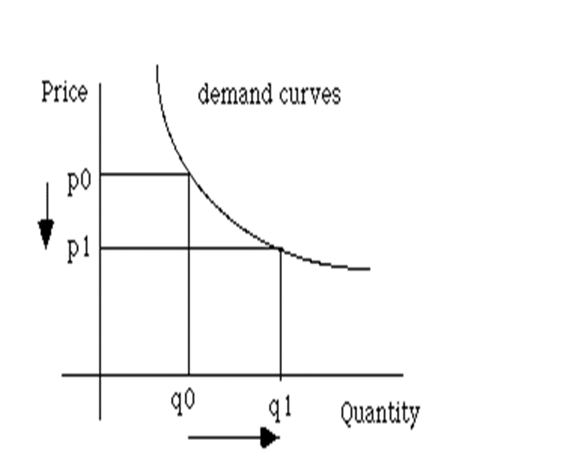 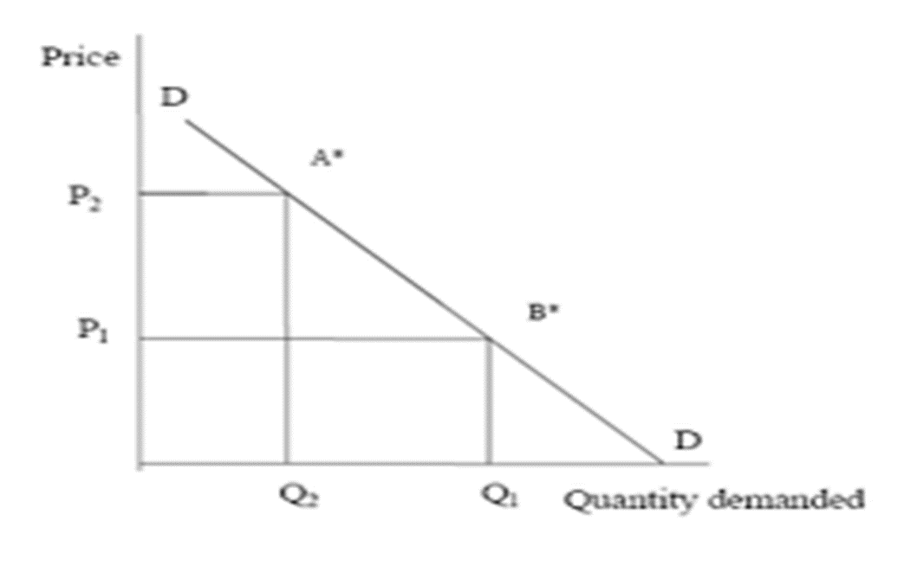

TYPES OF DEMAND

**Derived Demand**: Derived demand is the type of demand occurs as a result of demand for other commodities. The demand for one commodity will necessitate the demand for another commodity. For example, flour and sugar are demanded because there is demand for bread. Labour is demanded to construct the highway because there is a demand for good roads. So, labour, flour and sugar are “derived” demand commodities.

**Joint or Complementary Demand**: Joint demand is a demand, which occurs when two commodities that are related to each other are demanded at the same time. These two commodities are said to be complementary to each other as a change in the demand for one commodity will bring about a similar change in the demand for the other. Examples of joint demand are bread and butter, tea and milk, can and petrol. Sometimes they are described as “joint demand goods”.

**Competitive Demand**: When two commodities are fairly close substitutes to each other, they are in competitive demand. In other words, they serve the same purpose or perform a similar function such that an increase in the demand for one will result in a fall in the demand for the other. Examples of commodities that are close substitutes are Bournvita and Ovaltine, Omo and Elephant detergents; Butter and Margarine; etc. If the price of any of these pairs of commodities is high, the consumers may switch over to the other close substitute which has a lower price.

Composite Demand: Demand is said to be composite when a commodity is required to serve two or more purposes. For example, sugar is widely used in the home for beverages as well as in industries for making pastries and confectionery. If the industrial demand for sugar suddenly increases, it will affect the quantity of sugar demanded in the home.

MOVEMENT ALONG DEMAND CURVE

A movement along the Demand Curve refers to a change in both price and quantity demanded from one point to another on the curve. This deals mainly with the **price** of the commodity.

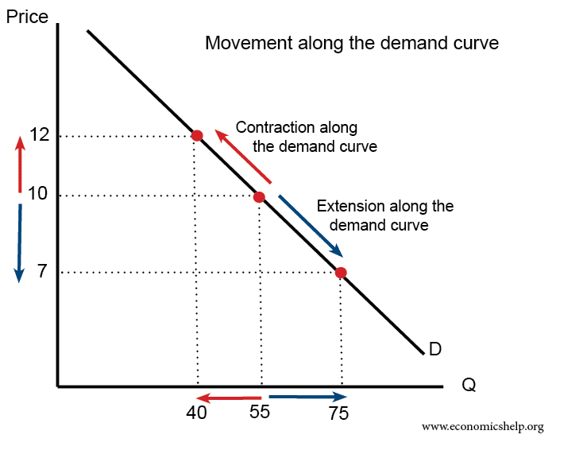

SHIFT IN DEMAND CURVE

This occurs when the entire demand curve moves to the right or to the left. A shift in the demand curve occurs because of a change in one or more factors other than price. This is based on the assumption that price is constant.

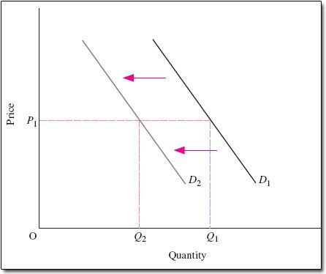

DIFFERENCES BETWEEN MOVEMENT ALONG A DEMAND CURVE AND SHIFT IN DEMAND

|  |  |
| --- | --- |
| MOVEMENT ALONG A DEMAND CURVE | SHIFT IN DEMAND |
| A movement along the demand curve refers to a change in both price and quantity demanded from one point to another on the curve. This deals mainly with the price of the commodity.  There is no new demand curve | This occurs when the entire demand curve moves to the right or to the left. A shift in the demand curve occurs because of a change in one or more factors other than price. This is based on the assumption that price is constant.  There is a new demand curve |

CHANGE IN QUANTITY DEMANDED

A change in quantity demanded is a movement along a/single demand curve. The main determinant of a change in the quantity of a commodity demanded is the price of the commodity under consideration. The quantity of a commodity demanded changes with price. More is purchased at a lower price than at a higher price.

A change in the quantity demanded is of two types.

1. Increase in the quantity demanded: There is an increase in the quantity demanded if the quantity purchased increases as a result of a decrease in the price of the commodity.
2. Decrease in the quantity demanded: There is a decrease in the quantity demanded if the quantity of the commodity purchase decreases as a result of an increase in price.

CHANGES IN DEMAND

This is a complete shift of demand curve to the right or left. There is a change in demand if the demand curve shifts to an entirely new position. There is a completely new demand Schedule and demand curve, showing that at the old price, more or less of the commodity would be purchased.

A change in demand is determined by other factors affecting demand except the price of the commodity e.g. change in taste and fashion, changes in population size, etc.

A change in demand is of two types:

1. Increase in Demand: If there is an increase in demand, the demand curve will shift to the right indicating that at the old price more of the commodity will be purchased. This is also called a rightward shift.
2. Decrease in Demand: if there is a decrease in demand, the demand curve will shift to the left, showing that at the old price less of the commodity is being purchased.

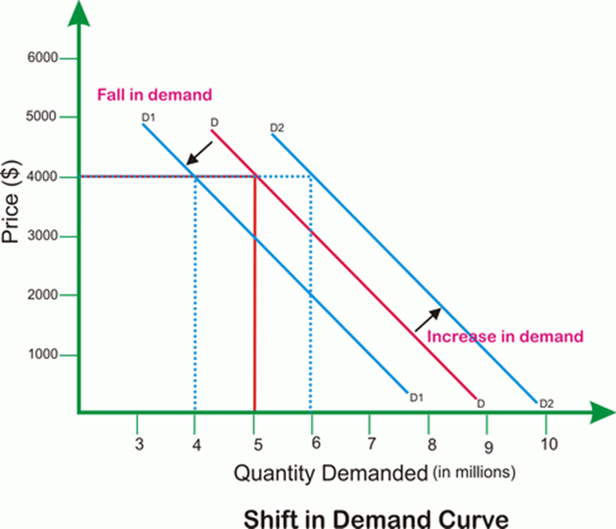

ABNORMAL DEMAND

Exceptional or abnormal demand is a demand pattern which does not abide by the laws of demand and therefore gives rise to the reversal of the basic laws of demand. Thus, at a higher price, increased quantities are demanded.

**Causes of abnormal Demand**

* Articles of ostentation
* Articles of necessity
* Future expectation
* Rare commodities

See page 215 to 217 for more details

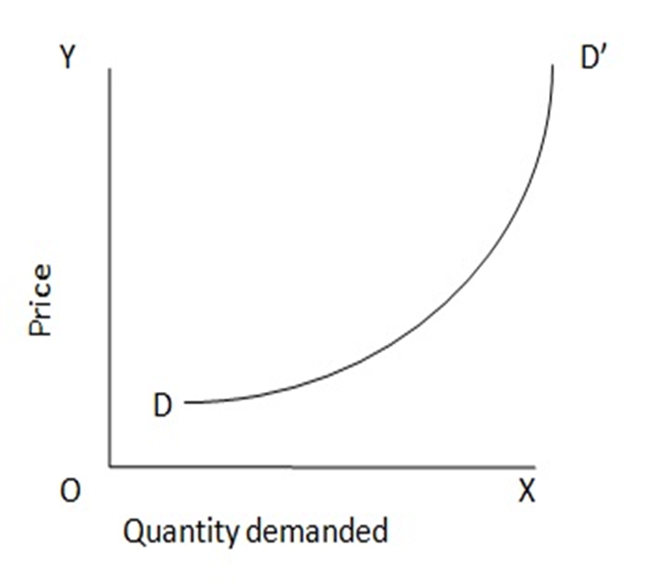

**Relationship between Law of Diminishing Marginal Utility and Normal Demand Curve**

The concept of the law of diminishing marginal utility can be used to explain the slope of the normal demand curve. The higher the marginal utility derived from the good, the higher consumers are willing to pay for it. The rational consumer aims at maximizing utility from the use of his resources. To achieve this, the consumer ensures that marginal utility (MU) of a good is equal to the price (P) of the good.

However, MU diminishes as increasing quantities of a commodity are consumed. Therefore, as the MU of a commodity diminishes, a consumer’s willingness to pay diminishes. This inverse relationship between the quantity demanded of a commodity and its price referred to as the law of demand.

This inverse relationship between the quantities demanded of a good and its prices is referred to as the law of demand while the inverse relationship between MU and quantities consumed is referred to as the law of diminishing marginal utility.

A reduction in price will encourage a consumer to consume a commodity whose marginal utility has fallen, hence marginal utility of a commodity must be equal to the price of the commodity (MUx = Px)

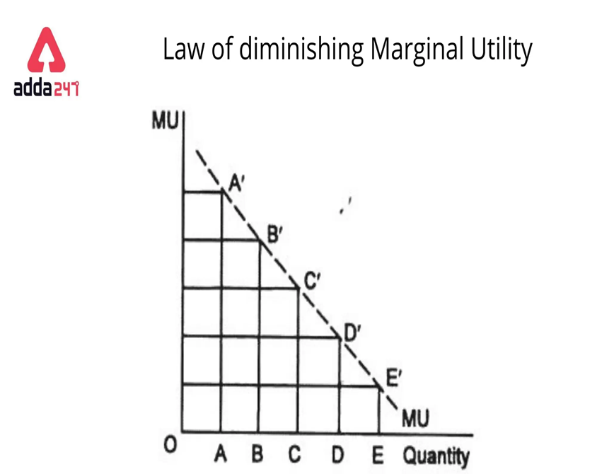

EVALUATIONS

1. Differentiate between needs/wants and demand.
2. State the law of demand.
3. Enumerate three factors that affect demand for a commodity.
4. Differentiate between movement along a demand curve and shift in demand.

ASSIGNMENTS

With the aid of a diagram explain demand schedule. Use the data in the schedule to construct a demand curve.

SUMMARY

Demand is an economic principle that looks at the effective desire of an individual to buy a commodity, supported by their purchasing power, at a particular price and time. Beyond price, some other factors also affect a consumer’s demand for a particular commodity. **Price** causes a **movement along** the demand curve while a **shift** in the demand curve is caused by the **other factors** affecting demand.

**WK 4: CONCEPT OF SUPPLY**

**Lesson Objectives;**

Students should be able to:

1. Define supply
2. Enumerate the factors affecting supply
3. State laws supply
4. Interpret supply curves from supply schedules
5. Differentiate between change in quantity supplied and change in supply;
6. Compare the various types of supply and their interrelationships
7. Explain factors that affect shift in supply and movement along the supply curve,
8. Plot the graphs of shift in supply and movement along supply curve.
9. Determine equilibrium price and points for a commodity

CONCEPT OF SUPPLY

Supply may be defined as the quantity of a commodity which a producer is willing and able to offer for sale at a particular price, and at a particular period of time.

LAWS OF SUPPLY

The law of supply states that, all things being equal, the higher the price, the higher the quantity of a commodity that will be supplied while the lower the price, the lower the quantity of the commodity that will be supplied ( offered for sale). This implies that sellers will supply more of an economic good at higher prices and vice versa

FACTORS THAT AFFECT SUPPLY

* Price
* Level of Technology
* Cost of production
* Government Policy
* Weather
* Taxation
* Price of other commodities
* Number of producers

TYPES OF SUPPLY

Composite Supply: occurs when a certain commodity can serve two or more purposes. In other words, the supply of the commodity for one purpose will greatly affect the supply of the same commodity for another purpose. For instance, crude oil. The supply of crude oil (petroleum) for the production of petrol will greatly affect the production of kerosene and other uses of Petroleum. If more petroleum is needed for petrol production, the price of petroleum will rise. People who require petroleum for other purposes will be faced with high prices.

Joint or Complementary Supply: Occurs when two or more commodities are produced and supplied from one source. An increase in the production and supply of one will automatically bring about an increase in the production and supply of the other commodities that are produced from the same source. For example, an increase in production and supply of petrol from petroleum can also lead to an increase in and supply of kerosene. Petrol and kerosene are obtained from the same source which is petroleum.

**Competitive Supply**: It is the supply of two or more commodities that serve as substitutes or alternatives to one another, e.g meat and fish, Omo and Elephant blue detergents, butter and margarine, Close Up and Macleans toothpastes, etc.

See page 35 for more details

SUPPLY SCHEDULE

This is a table which shows the relationship between the price of a commodity and the quantity supplied. It is a table view, showing the various quantities of a commodity which producers/sellers are willing to sell, at various prices, at a particular period of time.

There are two aspects of the Supply Schedule;

1. Individual Supply Schedule: This table shows the different quantities of a commodity which a producer offers for sale at various prices and at a particular time

|  |  |  |  |  |  |
| --- | --- | --- | --- | --- | --- |
| Prices per bag ($) | 100 | 80 | 60 | 40 | 20 |
| Quantity supplied | 50 | 40 | 30 | 20 | 10 |

1. Market (Aggregate) Supply schedule: this is a schedule of all producers/suppliers of a commodity in a market. It is a table that shows the total quantity of a commodity which all producers of that commodity are willing and able to supply at various prices at a particular period of time. It is a combination of all the individual suppliers in a market.

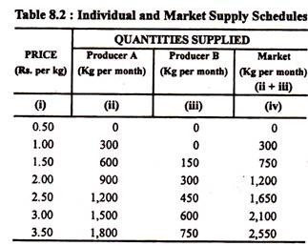

**NB: It follows the law of supply**

**SUPPLY CURVE**

This is a graphic representation of the relationship between price and quantity supplied, of a product at a particular time. It is a representation of the supply schedule, showing the various quantities of a commodity, which producers are willing and able to sell at various prices, at a particular time. Supply curve can be;

1. Individual Supply curve
2. Market (Aggregate) Supply curve

Nature of the Supply Curve

The supply curve is upward sloping, from the left to the right. This implies that the supply curve has a positive slope.

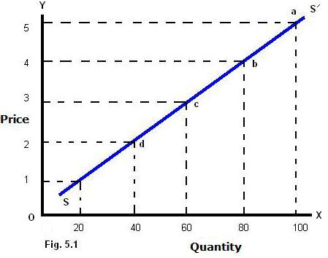 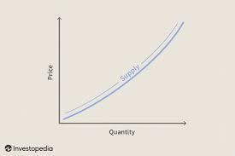

CHANGE IN QUANTITY SUPPLIED/MOVEMENT ALONG THE SUPPLY CURVE

A change in the quantity supplied of a commodity means a movement along a particular supply curve. It is determined by the price of the commodity.

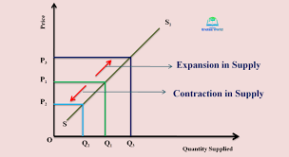

**A change in quantity supplied is of two types;**

1. Decrease in the quantity supplied: The quantity supplied decreases as a result of a decrease in the price of the commodity

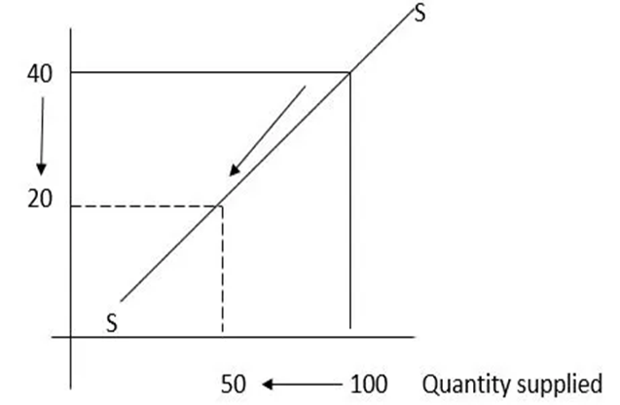

**2.Increase in Quantity supplied**: With an increase in the quantity supplied, the quantity offered for sale increase as a result of an increase in the price of the commodity.

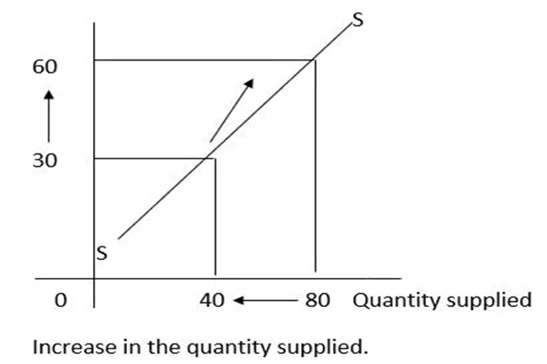

A SHIFT IN THE SUPPLY CUVE/CHANGE IN SUPPY

A Change in supply brings about a shift in the supply curve either to the right or to the left. With change in supply, the supply curve shifts to an entirely new position indicating that at each of the old prices more or less of the commodity will be supplied. It is determined by the factors affecting supply other than the price of the commodity.

A change in supply is also of two types;

1. **Decrease in supply**: With a decrease in supply, the supply curve will shift to the left, showing that at each of the old prices, less of the commodity will be supplied. This is a leftward shift.

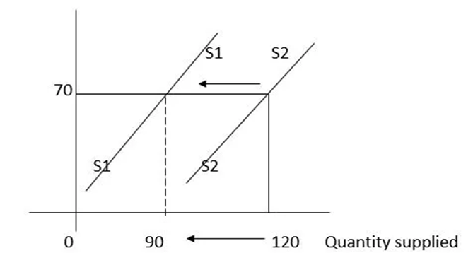

2.Increase in Supply: With an increase in supply the supply curve shifts to the right indicating that at each of the former prices, more of the commodity will be supplied.

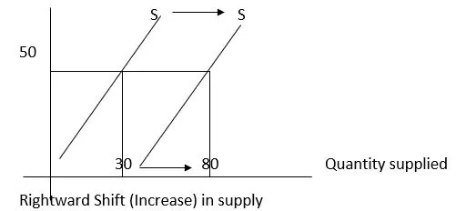

ABNORMAL SUPPY

Abnormal or exceptional supply is a supply that does not obey the law of supply. Hence, the higher the price, the lower the quantity supplied and the lower the price, the higher the quantity supplied.

**Causes of abnormal supply**

* Existence of fixed assets: fixed assets like land, its prices increases overtime without an increase in its size and this causes abnormal supply curve.
* Rising wages: at first, workers will increase number of hours worked but as wage rises further, workers will rather reduce the number of hours worked
* Target income
* Monopolistic practices

See page 221 to 222 for more details

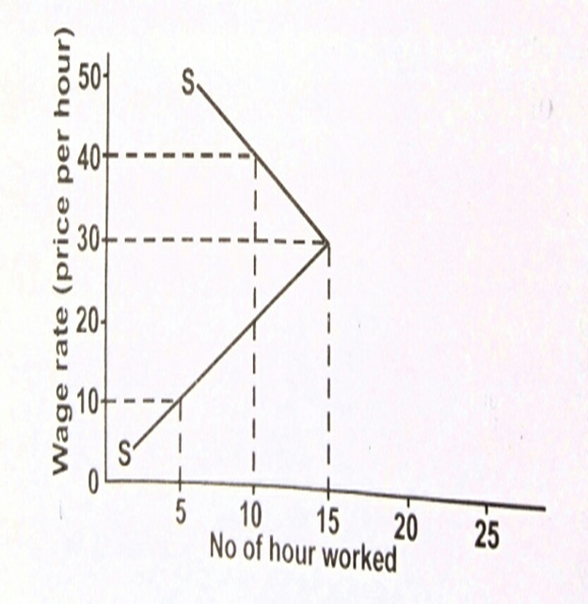

EQUILIBRIUM PRICE AND POINT

This refers to the price point at which the buyers are willing and able to buy, and the seller of that commodity is willing and able to sell.

Simply put, equilibrium price is the price that is determined by an interplay of the market forces (i.e. the forces of demand and supply). It is a price that equates demand and supply. At any point above the equilibrium price, sellers will supply more than is demanded, while any point below, buyers will demand more than is supplied.

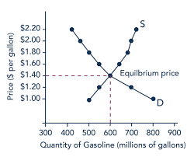 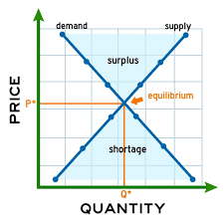

EVALUATION

1. What is supply?
2. State the law of supply
3. Explain two factors that affect supply.
4. Differentiate between demand curve and the supply curve.
5. Differentiate between movement along a supply curve and shift in a supply curve.

SUMMARY

The concept of supply attempts to explain the willingness and ability of a producer/seller to offer goods/services for sale at a particular price and time. In supply, there’s a positive relationship between price and quantity. The equilibrium price is determined at the point where the market forces interact. Any point below the EP would lead to a shortage while any point above will lead to surplus.

**WK 5: THEORIES OF PRODUCTION**

**Lesson Objectives;**

Students should be able to:

1. Explain the concept of production
2. Identify the types of production
3. State and explain characteristics and rewards of each factor of production
4. Discuss the concept of capital formation and viscous circle of poverty
5. Examine the factors mobility and efficiency

MEANING OF PRODUCTION

This refers to the creation of utility. It is any activity which results in the creation of goods and services and the distribution of these (goods and services) to the final consumers in order to satisfy human wants. All activities of production are aimed at satisfying human wants.

TYPES OF PRODUCTION

Production is grouped into two major categories, namely **direct** and indirect production.

**Direct Production** involves the production of goods and services only for family use or consumption. The goods and services are not for sale, rather they are to be used by the family.

**Indirect Production** consists of goods and services produced in large scale and is mainly for sale or exchange for other needs. It is divided into 3 groups **which are** primary, secondary, and tertiary production.

1. Primary/Extractive Production: This production refers to the extraction of raw materials provided by nature. It is concerned with the process of obtaining raw materials or resources in their natural state from the land, air, and water. E.g. agriculture, mining, fishing, lumbering, etc.
2. Secondary Production (Manufacturing and Constructive): This production involves the transformation or conversion of basic raw materials or semi-finished goods into final forms that are acceptable to the consumers. The services rendered here are either direct or indirect. E.g. processed food, houses, roads, clothes, cars, etc.
3. Tertiary Production: This production is concerned with the provision of commercial and professional services which are essential for proper running of the economy. The goods so produced at the primary and secondary levels are distributed to the people for consumption. E.g. wholesalers, retailers, transporters, soldiers, police, doctors, lawyers, musicians, teachers, hairdressers etc

FACTORS OF PRODUCTION

In the production of goods and services, a number of various factors of production need to be combined in various proportions. The factors of production are;

* Land
* Labour
* Capital
* Enterprise/Entrepreneur

LAND

Land, in economics, is defined as the various non-human natural resources found anywhere on earth. It includes the land surface, the rivers, seas, oceans, minerals, chemicals, fish, plants and everything provided by nature within the earth and the various environment.

**Characteristics of Land;**

* Land is immobile
* Land is fixed in supply
* Land is a free gift
* Land is subject to diminishing returns
* The value varies from place to place
* Land is heterogeneous
* The reward for land is ***RENT***

LABOUR

This is the factor of production that represents all human effort, both physical and mental, directed towards the production process, usually for a reward known as wages and salaries.

Human beings provide the necessary labour, which combines with other factors of production to provide goods and services.

**Characteristics of Labour**

* Labour is mobile
* Labour has feelings
* Labour is skillful
* Labour is a human factor
* Requires motivation
* Perishable
* Has initiative
* The reward for labour is ***WAGES/ SALARIES***

CAPITAL

This is all man-made assets used in the production process. It is a form of wealth, set aside for the production of further wealth. A stock of physical assets, accumulated by society to facilitate the production of goods and services.

Capital is also known as Investment goods or Producer goods.

Characteristics

* Capital is man-made and accumulated over the years.
* Capital is durable.
* It exists in different forms.
* Capital is subject to depreciation.
* Some forms of capital are specific and immobile e.g. buildings, machinery, while others flow freely e.g. cash
* It ensures large scale production.
* . The reward for capital is **INTEREST**

ENTREPRENEUR

An entrepreneur is the factor of production, responsible for coordinating and organizing all the other factors of production, in order to produce goods and services.

He/She organizes the human and material resources for the production of goods and services, taking major decisions within the business and bearing the risks associated with his decisions. He also provides the capital and earns **profit** as his reward.

Characteristics

* Risk Bearing
* Organizing
* Decision making
* Control of all the other factors of production
* Provision of capital
* The reward for entrepreneur is PROFITS/LOSS

CAPITAL FORMATION/ACCUMULATON

Capital formation or capital accumulation refers to increasing a country’s stock of **real capital**. That is, it refers to increasing the **net investment** in form of fixed assets.

In most developing countries, the low rate of capital accumulation is as a result of what we call “**the vicious circle of poverty”**

The reasons for low capital formation in West Africa is because of the following factors;

* Existence of a Vicious circle of poverty
* Wasteful expenditure
* Higher propensity to consume than save
* Relative poverty(inequitable distribution of income)
* Low savings etc….

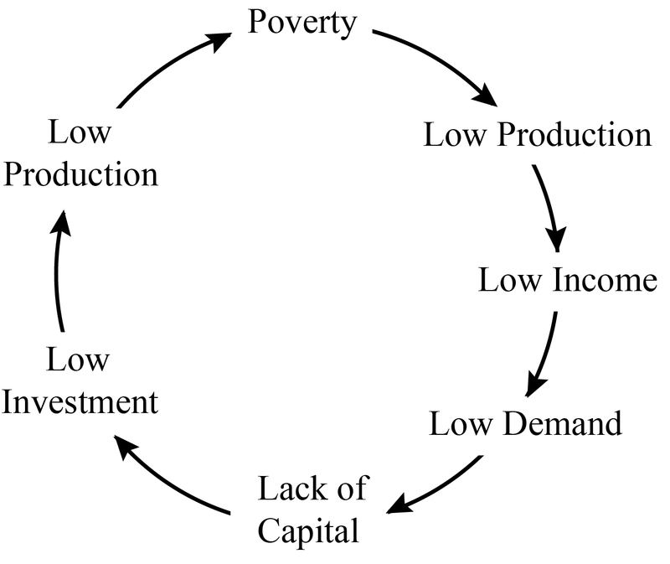

Diagram Showing Vicious Circle of Poverty

FACTOR MOBILITY AND EFFICIENCY

Factor mobility measures the extent to which factor inputs such as land, labour and capital can easily switch between alternate uses with no loss of efficiency.

Labour Mobility

This is the ease with which labour can move from one geographical area to another ( geographical mobility of labour) or from one occupation to another ( occupational mobility of labour).

Factors Affecting Mobility of Labour

* Cost of transportation
* Accommodation problems
* Wage rate
* Discrimination
* Language barriers
* Family/cultural ties
* Climatic conditions, etc.

Labour Efficiency

This is the ability of labour to increase output without increasing its quantity.

Ways of Improving Efficiency of Labour

* Assurance of job security
* Increased level of technology
* Efficient management
* Promotion, etc

Meaning of Related Words

Product : A product is something that is made or produced to be sold or used. It can be a physical item like a toy or a piece of clothing, or it can be a service like a haircut or a software program. Products come in many different forms and serve various purposes.

**Skilled Labour:** This category of labour mostly use their mental effort in productive activities, having undergone long and specialized trainings in institutions of higher learning. Their jobs are popularly referred to as White collar jobs.

**Unskilled Labour**: This category requires little or no formal education/training. They make use of physical effort or energy in the production process. Their jobs are popularly referred to as Brown collar jobs.

**Semi-Skilled Labour**. This category of labour has undergone more trainings than the unskilled but not as specialized as that of the skilled labour.

Fixed Capital: Durable assets of the business that are not used up in the course of production, renewal is at fairly long intervals e.g. Land, building, machinery etc.

**Circulating/Circulatory/Working capital**: Capital required for the day-to-day running of productive activities e.g. money. This is capital used up in the course of production e.g raw materials, diesel/fuel etc.

**Social Capital:** All forms of capital, provided by the government, that aid production e.g. electricity, roads etc

Producer Goods: These are goods that are required for the production of other goods. They do not satisfy human wants directly but are desired because they assist in the further production of other goods. It is also known as **Capital goods.** Examples include buildings, tailor’s tools, machines etc.

Consumer Goods: These are goods and services that can satisfy the consumers’ immediate needs. They do not need further processing before they can be used by the consumers e.g. cars, milk, cake, the services of a nurse, lawyer etc.

Durable Goods: Also known as **consumer durable goods**, these are goods that can be used over and over again before they get worn out.

Non-Durable Goods: These are goods that are used up from one use or used up at once. They are also known as Perishable goods.

EVALUATION

1. What is production
2. List the factors of production and their rewards
3. List 2 characteristics each of the factors of production

ASSIGNMENTS

1. Write down the uses/importance of all the factors of production. To be written in your notes
2. Read up on Wealth, Ownership of wealth and the relationship between wealth and capital (See page 55 for details)
3. How to solve the problem of the vicious circle of poverty (See page 57-58 for details
4. Reasons for low personal savings in West Africa (See page 58-59 for details.)

SUMMARY

Production involves all human activities aimed at transforming raw materials into semi-finished or finished goods, and the distribution of these goods to satisfy wants.

The importance of production cannot be overemphasized as it has made people have access to a comfortable life, right from the food we eat to the other products or services we use to satisfy our numerous wants*.*

**WK 6: DIVISION OF LABOUR AND SPECIALIZATION**

**Lesson Objectives;**

Students should be able to:

1. Define division of labour
2. Differentiate between specialization and division of labour
3. Evaluate the advantages, disadvantages and limitation of division of labour

MEANING OF DIVISION OF LABOUR

This is the breaking down of a production process, into different stages, such that each stage is handled by a particular individual, unit or department.

Division of labour is a complex process, mostly practiced in industrialized communities, where different workers handle different parts of the production process.

ADVANTAGES OF DIVISION OF LABOUR

* Increase in production (OUTPUT)
* It saves time
* It helps workers develop greater skill on the job
* Lower unit cost
* It leads to specialization
* Less fatigue
* Production of standard goods
* Employment creation
* Development of new Technology

DISAVANTAGES

* The job can become boring due to repetition ( Monotony)
* Reduction in employment opportunities due to mechanization of most processes.
* Problem of mobility of labour.
* Problems from increased interdependence.
* Consumer choices are restricted as a result of standardized products.
* It can lead to wastage.
* Possibility of industrial action

LIMITATIONS OF DIVISION OF LABOUR

* The size of the market
* Efficiency of the management team
* The nature of the products
* Level of technology
* Availability of capital
* Availability of labour
* Government policy
* Development of commercial sector

MEANING OF SPECIALIZATION

This is the process by which an individual, a firm or a country, concentrates his/its productive effort on a particular line of production, in which he/it has the greatest advantages over others. Here, one limits his productive effort to a particular aspect of economic activity, such that he builds expertise in that area.

TYPES OF SPECIALIZATION

**Specialization by Process**: production process is divided into different operations or stages and each worker. E.g Printing Company

**Specialization by Gender**: This is the type of specialization in which certain occupations are exclusively either for males or females as dictated by law/custom. E.g Males drive trailers (distribution chain)

**Specialization by Product**: This is the type of specialization in which a producer concentrates on the production of a particular product. A firm can concentrate on producing coca-cola product while another firm can concentrate on producing Hero

**Geographical or Territorial Specialization**: a type of specialization wherein a region specializes in producing a particular product

POINT TO NOTE: Division of Labour and Exchange:

Division of labour and specialization create a situation where people have to depend on others to get the goods and services they do not produce. This interdependence gives rise to exchange between individuals, firms and countries.

As large quantities of goods are produced due to division of labour, these goods need to be exchanged for other commodities which the individual, firm and country cannot produce.

EVALUATION

1. Define division of labour
2. Differentiate between division of labour and specialization
3. List factors that affect division of labour

SUMMARY

With the growth of the economy, production moved away from simply production in which one man played all the parts, to a system whereby communities had different people specializing in different fields, so that each person could exchange monetary rewards for commodities which they couldn’t produce.

Division of labour therefore leads to specialization, and ultimately exchange.

**WK 7: SCALE OF PRODUCTION**

**Lesson Objectives;**

Students should be able to:

1. Enumerate the advantages and disadvantages of large scale production
2. Compare and contrast differences between large scale and small scale
3. Compare the internal and external economies of scale in production and their effects;
4. Analyse production function using isoquant curve
5. Compare the different types of returns to the scale and their implications;
6. Identify the factors affecting productivity

**Definition of Terms**

**Factory/Plant**: The place where the actual production takes place. It contains all the machines, equipment and tools in the production process.

**Firm**: This is an independently administered business unit, capable of carrying out production, construction or distribution activities. Firms may be large or small, depending on the capital outlay and the level of production.

**Industry:** This is a collection/group of firms, producing similar commodities or offering similar services e.g. the banking industry

MEANING OF SCALE OF PRODUCTION

This refers to the quantity of a commodity that a firm can produce, in relation to its size. They are categorized into 2: large scale (If a firm carries on production with a large number of plant) and small scale (if the production is small and the size of plants are small).

FEATURES OF LARGE SCALE PRODUCTTION

* It requires large capital
* They are mainly involved in secondary and tertiary production
* They require large market
* They usually employ a large number of workers
* They employ complex technique of production
* They undertake various forms of research and awareness

ADVANTAGES

* They enjoy a larger capital base
* The firms enjoy economies of large buying and selling
* The Liabilty of the owners are limited to their shares
* They can afford to buy new machineries

DISADVANTAGES

* The market size and capital can limit the scale of production
* It can lead to monopoly on the part of the some firms

ECONOMIES OF SCALE

It refers to the growth of a firm as a result of the increase in its productive capacity, which leads to an increase in output and a decrease in its cost of production per unit of output. These are the internal and external cost-saving benefits that accrue to a firm as it expands in size.

Economies of scale are of 2 types;

1. Internal Economies of scale and internal diseconomies
2. External economies of scale and external diseconomies

INTERNAL ECONOMIES OF SCALE

This refers to the cost-saving advantages, enjoyed by a firm, as a result of producing in large quantities. It is also known as the **Economies of Large scale production**. This benefit occurs within a firm.

The advantages include;

* Marketing Economies
* Risk bearing economies
* Financial economies
* Managerial economies
* Welfare economies
* Research and development economies

INTERNAL DISECONOMIES

This refers to those disadvantages that arise as a result of large scale production. This happens when an expansion leads to less efficiency and increase in the cost per unit of an output as a result of managerial problems. They include;

* Slow response to change
* Lack of motivation
* Bureaucracy which can lead to lack of initiative
* Difficulty in management and rise in administrative cost
* Monopoly of market and unfair competition
* Over production and waste of resources

EXTERNAL ECONOMIES

This refers to the benefit that firms producing similar/identical goods and concentrated in one geographical area can enjoy. It is the benefit accruing to an industry, as a result of its localization in a particular area. External economies are mostly derived from industrial estates. These benefits include;

* Development of skilled labour force
* Provision of common services
* Development of organized market
* Development of Subsidiary firms
* Government influence

EXTERNAL DISECONOMIES

This refers to the disadvantages a firm experiences when the activities of one or more firms within the industry, increases the cost of production or output of the other firms within the same location. They include;

* Pollution
* Limited natural resources
* Pressure on infrastructure
* Unfavorable government sanctions

PRODUCTION FUNCTIONS

This is used to present the maximum quantity of output produced at a time as a function of the quantity of the variable input that are used. It is given by the formula

**Q=F (Variable Factor)**

For example, assuming the variable input is labour which may be a variable factor, the production function will be **Q=F(LABOUR)**

This shows that the quantity of goods or services produced is a function of the quantity of labour employed

There exist cases where more than one inputs are involved, the production function will be

**Q=F (Z1, Z2……..ZN)**

Where q represents the quantity produced at a particular time and Z (1…..n) stands for the quantity of a particular input.

|  |  |  |
| --- | --- | --- |
| Units of labour | Units of capital | Unit of corn |
| 50 | 15 | 50000 |
| 100 | 10 | 50000 |
| 150 | 8 | 50000 |

The table above shows different combinations of inputs which will produce the same quantity of corn.

NB: The isoquant curve will be drawn in class.

FACTORS THAT DETERMINE LEVELS OF PRODUCTION

There are several factors that determine the level of production, such as:

* the availability of resources
* Technology
* Labor
* Capital
* Natural factors
* Provision of social amenities, etc.

EVALUATION

1. Distinguish between small scale and large scale firms
2. Differentiate between external and internal economies of scale internal economies of large scale production

SUMMARY

Economies of scale occurs when a business benefits from the size of its operation. Its unit cost decreases as the company grows. A firm’s scale of production, and the industry in which it operates, can have both positive and negative impacts on its operations. The management must therefore take extra care to ensure that risks are minimized, while seeking ways to maximize profit.

.

**WK 8: ECONOMIC SYSTEMS AND BASIC ECONOMIC PROBLEMS OF EVERY SOCIETY**

**Lesson Objectives;**

Students should be able to:

1. Define economic systems
2. Enumerate the advantages and disadvantages of each of the economic systems
3. Apply the knowledge of economic systems to contemporary issues in Nigeria
4. Proffer solutions to economic problems in different economic systems
5. Discuss the basic economic problems of society
6. Suggest ways of efficient allocations/use of scarce societal resource
7. State examples of different economic systems and how they solve their economic problems

MEANING OF ECONOMIC SYSTEM

Economic systems are the methods societies and governments use to organize, allocate and distribute goods, services and resources across locations. An economic system serves as a regulatory system for controlling different aspects of production and distribution, including capital, labor, land and other physical resources.

TYPES OF ECONOMIC SYSTEM

1. CAPITALISM

In a market economic system, or a “free-market system,” communities, firms and proprietors act in self-interest to decide how to allocate and distribute resources, what to produce and who to sell to. Governments in market systems typically have little intervention in how businesses operate and generate income, however, can regulate factors like fair trade, policy development and honest business operations.

**Features**

* Private ownership of properties
* Existence of competition.
* Maximization of profits
* Individual satisfaction
* Production and consumption are regulated by price system:

**Advantages**

* Provides incentive for innovative entrepreneurship
* Gives consumers a choice in goods, services and purchase prices
* Creates market competition for resources, resulting in quality offerings and efficient use of resources to produce goods
* Inspires research, development and advances in goods and production of goods

**Disadvantages**

* Highly competitive markets can cause a scarcity in resources for disadvantaged individuals
* Potential for monopolizing of industries and niches, such as technology, health care and pharmaceuticals
* Can increase income disparity by placing focus on economic needs over societal, community and human needs.

SOCIALISISM/COMMAND/CENTRALLY PLANNED

In command economic systems, governments and centralized powers control much of the economic processes, including allocating and distributing resources, goods and services. In a command economy, the government plays a key role in directing and intervening in business processes that provide essential goods and services to the community.

**Features of Socialism**

* Joint decision-making
* Non-profit motive
* Promotion of welfare
* Freedom of choice
* Non-price competition
* Equitable distribution of income.

**Advantages**

* Creates potential for mass mobilization of necessary resources due to government control
* Creates additional jobs for community members and citizens due to increased mobility of resources
* Focuses on benefits to society over individual interests
* Encourages more efficient use of valuable resources

**Disadvantages**

* Creates scarcity due to an inability to plan for individual needs
* Forces government rationing due to inability to calculate demand on set prices
* Eliminates market competition, resulting in a lack of innovation and advancement
* Inhibits employees' freedom to pursue creative jobs and careers.

MIXED ECONOMY

Mixed economic systems combine two or more economic practices to form one central system. Traditionally, a mixed economy consists of a market and command economy combined to form an economic system where the market is generally free from government or national ownership. However, the government can still have control over essential industries and sectors like transportation and defense.

**Advantages**

* Allows for private companies to operate more efficiently and reduce operational costs because of less government oversight
* Creates an outlet for market failures through allowing certain government intervention
* Enables governments to create net programs like social security, health care and food and nutrition programs
* Gives governments power to redistribute income through tax policies, reducing income disparities

**Disadvantages**

* Government intervention can be too frequent or not frequent enough, creating an imbalance
* Creates potential for government subsidiaries within state-run industries
* Can cause subsidized government industries to go into debt with a lack of competition in state-run industries

BASIC ECONOMIC PROBLEM

They **refer** to the problems people encounter in the society while attempting to satisfy their numerous wants with the limited resources available to them. These Basic economic problems of society include what to produce, how to produce, for whom to produce and efficient use of resources.

WHAT TO PRODUCE

This is borne out of the limited wants due to limited resources. Determining what to produce, therefore, heavily depends on the multiple demands of people and the readiness of producers to satisfy these demand.

**Factors Which Determine What to Produce**

1. **Consumer needs:** The producers will have to consider the needs of the consumers. They have to decide what goods and services required by the consumers
2. **Market demand:** In economics, the principal variable which signals what to produce is the price which such a commodity commands in the market. Commodity with positive price (price above zero) tend to be produced. For a commodity to be produced, it must therefore possess an effective demand. For example is a producer who wishes to set up a piggery to produce pork in an essentially Islamic country like Iran or Saudi Arabia. The effective demand is almost nil and so is the price. Price therefore represents a strong indicator of what to produce.
3. **Availability of Resources:** Availability of resources also play a vital role in such a decision. For example, an investor with N1 million to invest would neither think of establishing a ship-building yard nor locomotive production. These ventures are capital intensive and the absence of fund may rule out their production.
4. **Consumer Income:** In deciding what to produce, the producers normally take into considerations the earnings of consumers in the society. Producers normally ask themselves this question: Are the consumers b earning enough income to be able to purchase the goods and services at a given price when produced? If yes, they go ahead but if no, they may not produce.

HOW TO PRODUCE

Even after the question of what to produce have been solved, the question of how to produce it still arises. This could even be seen as a more crucial question because certain non-economic factors as ideology come openly into play.

**Factors Which Determine How To Produce**

1. **Technological Advancement:** The method of production adopted by an individual, firm, or state depends on the level of technological development of the state. Developing countries usually adopt labour intensive mode of production while developed countries adopt capital intensive mode of production.
2. **Relative Cost Of Factors Of Production:** The cheaper the relative cost of factors of production, such as labour, capita, land, etc., the more the production of goods and services to satisfy human wants but when the factors of production is high, very little production will be attained.

FOR WHOM TO PRODUCE

Before engaging in production, investors are expected to have carried out a feasibility studyaboutthe nature of the business. One of those things you do in the study is to identify prospective consumers of the commodity to be produced. Investors try to ascertain if the demand of such prospective buyers is enough to guarantee the firm some reasonable level of returns. If not, the investors turn to other goods which will yield an appropriate level of return.

**Factors Which Determine For Whom to Produce**

1. **Satisfaction of Wants:**All the goods and services produced either by individuals, firms or government must satisfy the needs or wants of the society.
2. **Level of Income:**The higher the level of income of the consumers, the more they are able to buy goods and services produced. But if the level of income is low, the purchasing power will equally be low and this will lower the rate of production of these goods and services.
3. **Type of Economic System:**In the capitalist and mixed economies, who gets what depends on the prices of the various products and amount available to each individual, but in a socialist economy, the state normally introduces a quota system in the distribution of goods and services among the people.

EFFICIENCY OF RESOURCES

In production, efficiency of resources used refers to the optimum use or combination of factors of production to achieve higher and better output at a reasonable cost. Since the resources available in the society are limited relative to demand for them, it becomes a wise decision to ensure that these limited resources are efficiently used to produce the desired goods and services.

Efficiency of resource use in production therefore ensures that the given level of output is achieved using the least possible cost/input.

**Factors Which Determine Efficiency of Resource Use**

* **Quality Of Labour**
* **Techniques Of Production**

**HOW EACH ECONOMIC SYSTEM SOLVES FUNDAMENTAL ECONOMIC PROBLEMS OF SOCIETY**

The ways by which each economic system solves fundamental economic problems of society are as follow:-

What to produce, How to produce and for whom to produce

* **In capitalist economic**, individual propelled by the profit motive to decide what should be produced and how best to produce it. Here, a person consumes whatever his income allows. Consumer determines what to produce.
* **In socialist economic**, price does not play a crucial role as state decides what to produce and the method of production to be adopted. The government often introduces rationing of goods among the people.
* **In mixed economic**, the state is guided by welfare consideration and private individuals by the profit motive. People consume whatever their money can buy but the state often provides some subsidized goods and services to all members of society.

EVALUATION

1. Differentiate between capitalism and socialism

2. List the basic economic problem of the society

ASSIGNMENT

Discuss on communism. Write down the features, advantages and disadvantages

NB: write it in your notes.

SUMMARY

Economic systems are the methods societies and governments use to organize, allocate and distribute goods, services and resources across locations and the problem of how to allocate these resources effectively depends on the system practiced.